DATABASE: SuperMart
CAPSTONE PROJECT – FAITH MANGOPE TLI
Student: Manese Lydia Mohapi
Date: 20 Aug. 26

The Beginning of My Projects where i started with creating my database.
Created my first table named “Customers”.
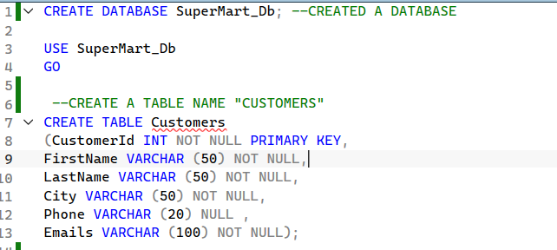

Created My Second Table named “Orders”.
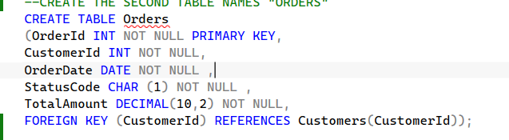
Data Insertion on the Customers Table. 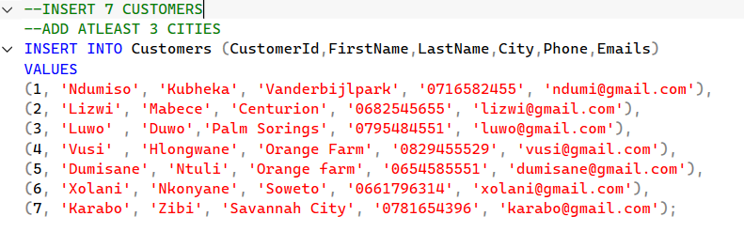

Data insertion on the Orders Table .
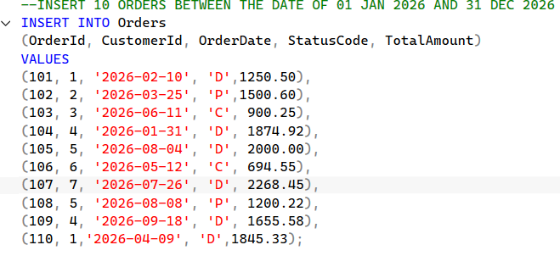
Altered the Table to Set the City to Johannesburg as requested.
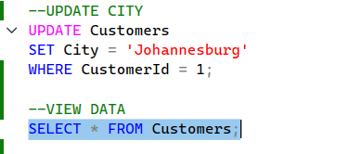
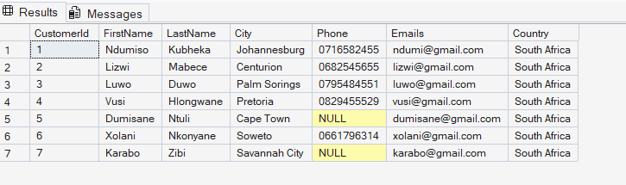
Updated the Customers Table and Set the city to Cape Town and Pretoria 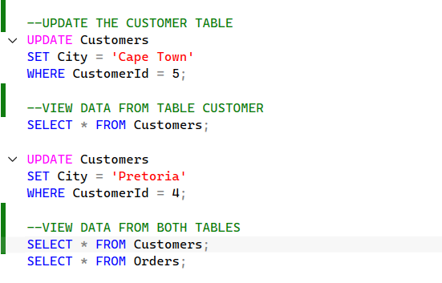
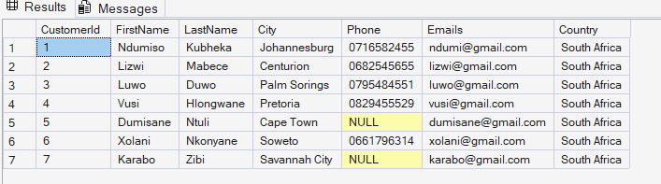
Viewed data from both the tables at the same time.
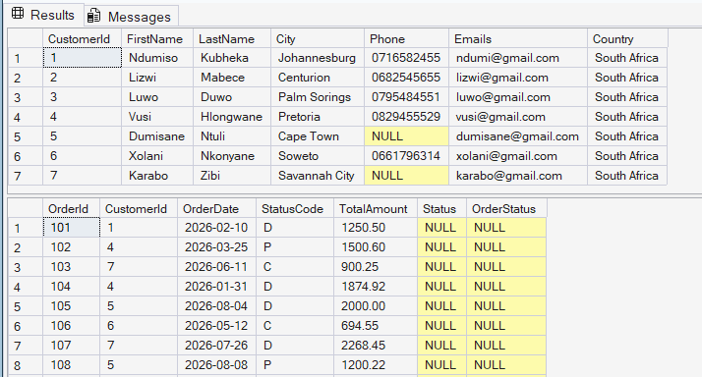
Updated the Customer Table to Set phone number to Null.
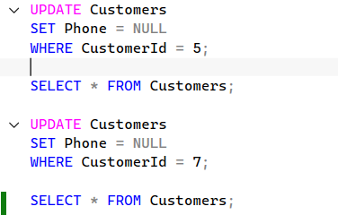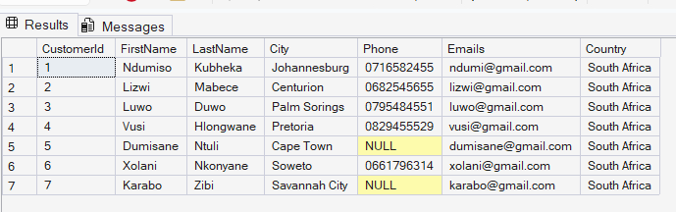

Altered the Customers Table and added the Country and Set to “South Africa” and should not be null.
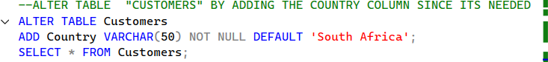
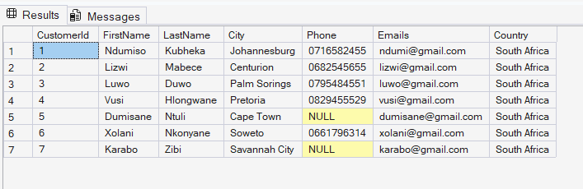
Used Coalesce to set “No Phone Number”.
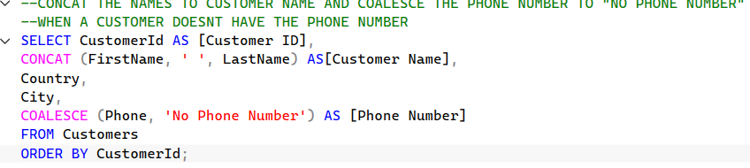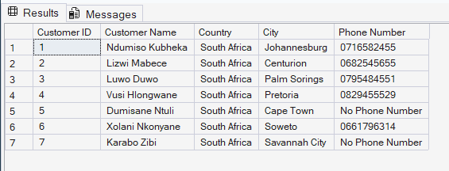
Filtering Data using the SQL Operations.
Implemented the IN operator.
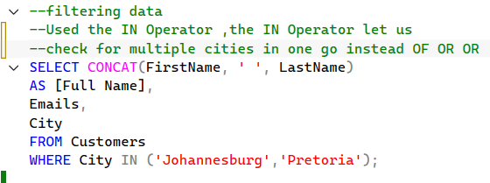
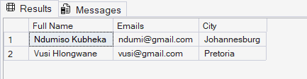

Used the BETWEEN operator.
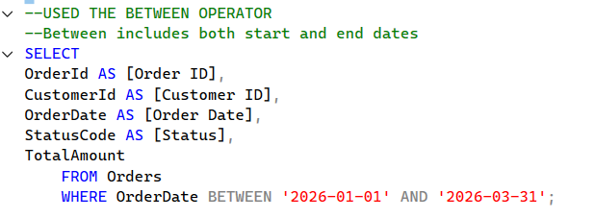
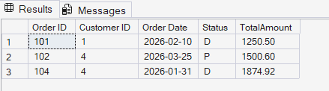
Implemented Joins ,used the Inner join.
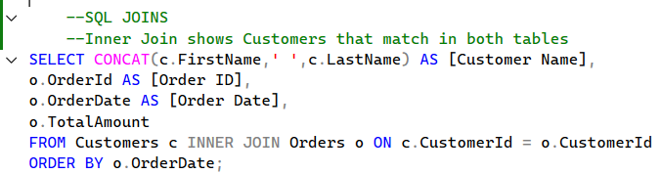
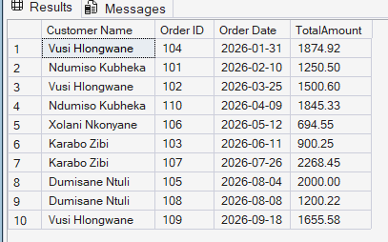
Implemented the Left Join.
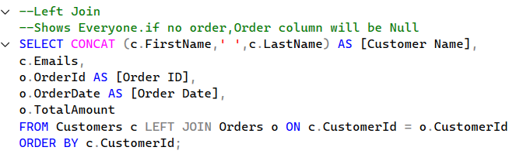
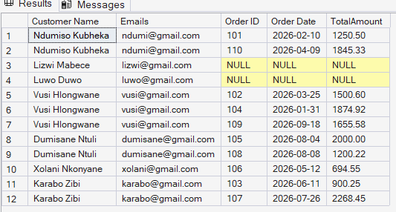

Implemented the Right join.
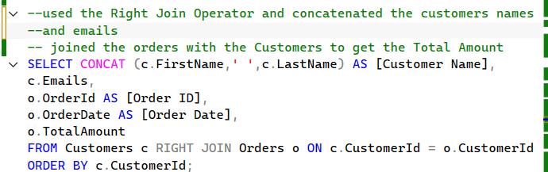
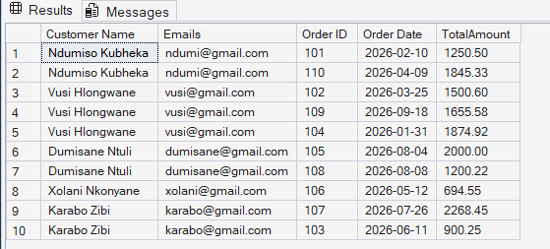
Used the Full Join
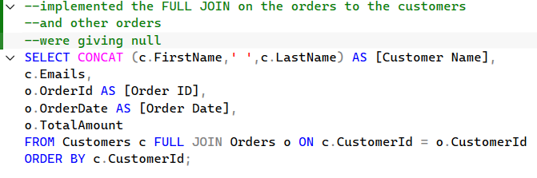

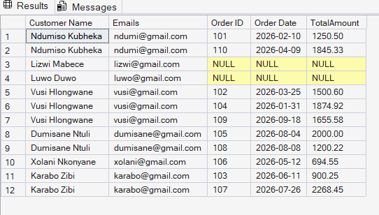
Activity 6 – Used the UPPER operator
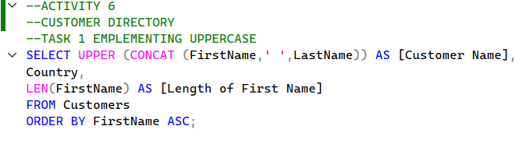
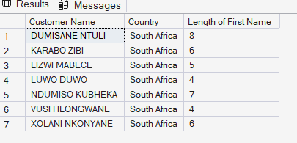
Arranged the table by Descending order Grouping it By Country
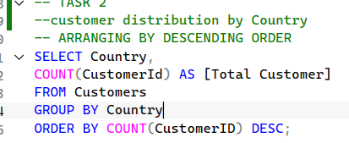
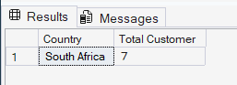
Order Summary Report for Finance
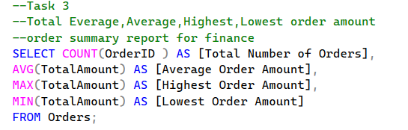
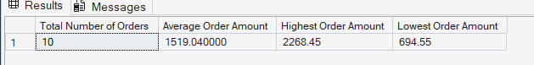
Order Activity for Operations Manager
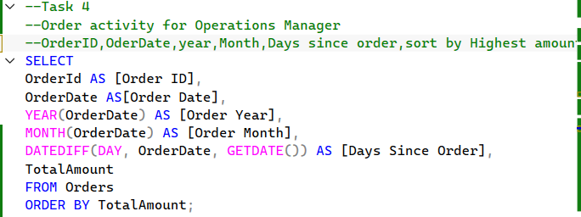
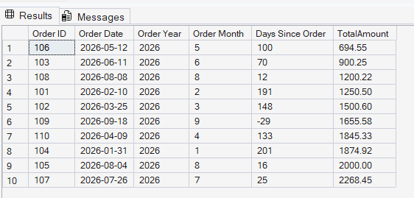

AVTIVITY 7 – Section A Query 1
IN operation implemented.
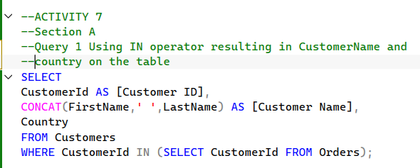
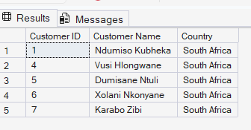
Query 2 – used the EXIST Operator
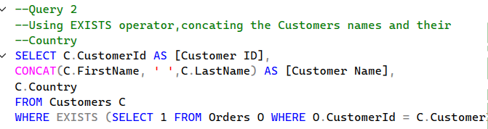
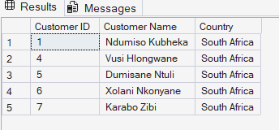
SECTION B- Reusable Report
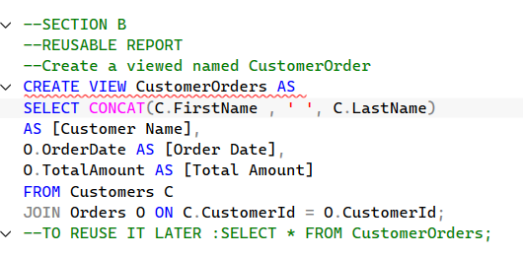
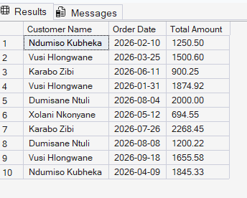
CTE for Total number of orders per customer
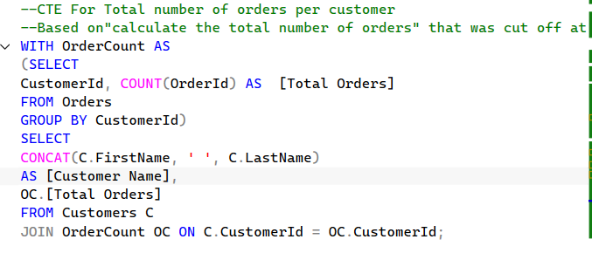
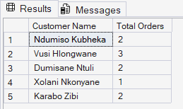
SECRTION B:2 CTE – Total amount of orders per customer
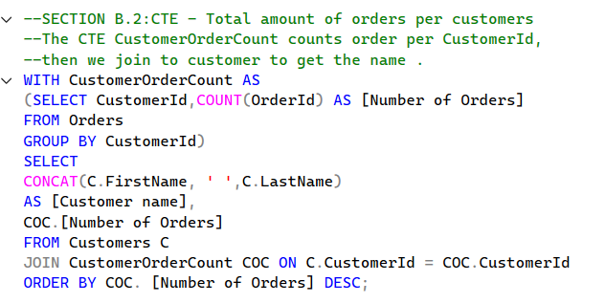
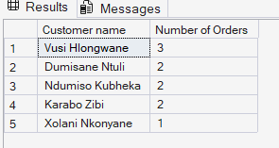
SECTION C : STORED PROCEDURE
Altered the order table to add Order Status.
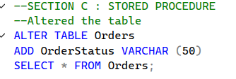
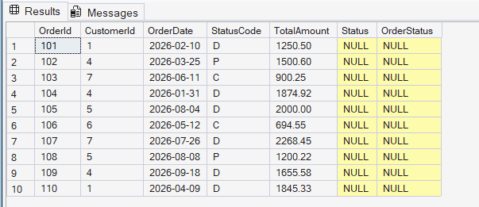
Procedure that takes customer ID and returns all orders for that customer
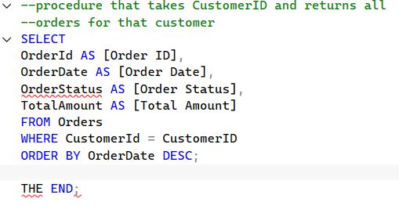
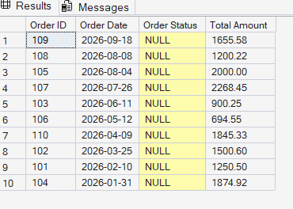

THE END..

